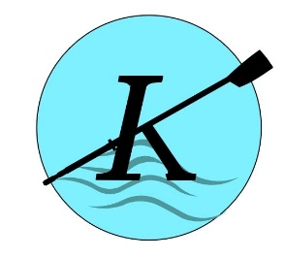
Kenmore Rowing Club
Junior/Youth Registration
Participant Information

Last name:__________________________________First name:_________________________

Gender:_____________________ Age: _____________________

Address:________________________________________________________________________________________

Phone number:_________________________________ Email:____________________________________________

How did you hear about us?__________________________________________________________________________

Float test: (Initial)
______I understand that I must pass a float test, which consists of treading water for 10 minutes and then putting on a PFD. I must have the form signed by a certified lifeguard. This must be done before I may participate

Waiver: (Initial)
_______I understand that I need to sign the USRowing waiver of liability before I may participate.

Medical Conditions: Please list any current injuries, physical/mental limitation, allergies, or medical information that the coaching staff should know to ensure your safety or that might affect your ability to participate.

__________________________________________________________________________________________________

Emergency Medical Treatment Waiver: In Case of Emergency, please contact:

Name:____________________________________________________________ Relationship: _____________________

Phone:___________________________________________

Publicity Permit
In consideration of this being an amateur activity, I release the rights of any and all photographic material, motion picture, video tape, recordings and/or computer information organizers may wish to release for this event without obligation to me. I understand that these publications might include city/school/crew information or promotional brochures, pictures, newspaper articles, website postings, and/or newsletters relating to any of the above activities.
___________ I hereby give my permission ____________ I hereby do not give my permission

_________________________ Date _______________________________ Signature

Please make checks ($150.00) payable to: Kenmore Waterfront Activities Center (memo line: KRC)
Mail form and payment to Kenmore WAC 7353 NE 175th St., Kenmore WA 98028

