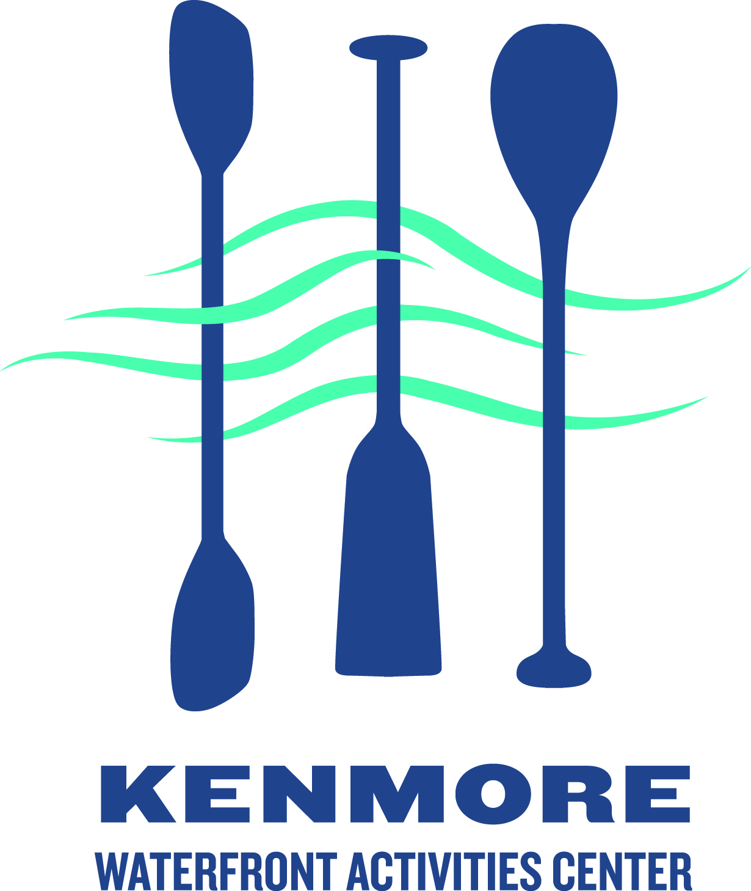
Kenmore Rowing Club
Youth Learn-to-Row Registration

Participant information

Last name:_____________________________ First name:______________________________

Sex: M F Age as of July 1 2017: ___________ Grade fall 2017: ________

Parent/guardian name: ________________________________________

Street Address ___________________________________ City _____________ Zipcode __________

Parent phone number: (_______)____________________ email: ______________________________

How did you hear about us? ___Internet ___Flyer ___Word of mouth Other ___________________

Session (check one): ___ July 24-28 9am-noon $150
[Contact debras98@frontier.com for scholarship information]

Swimming acknowledgement:
_____ I understand that my child must pass a 10-minute float test (or provide other evidence of
Initial swimming ability such as from a swim coach or instructor) PRIOR to the first day of class. The
float test can be taken at a number of Seattle Parks and Recreation Pools
http://www.seattle.gov/parks/pools.asp - call the pool for a schedule (see
http://www.seattle.gov/parks/teens/pdf/forms/float_test.pdf)

Waiver acknowledgement:
_____ I understand that I will need to sign the USRowing waiver of liability before my child participates
Initial

Medical conditions: please list any current injuries, physical/mental limitations, allergies or medical information that the program director and coaching staff should know to ensure your son/daughter has a safe and productive camp experience____________________________________________________

____________________________________________________________________________________

Emergency Medical Treatment Waiver - In case of emergency, please contact:

Name: ____________________________________ Phone: ____________________________

I authorize emergency medical treatment if qualified medical personnel consider treatment necessary providing I am unavailable to respond/advise or my emergency contact is unavailable to respond/advise.

Parent/Guardian Signature: _________________________________Date: _____/______/_______

Please make check payable to: Kenmore Waterfront Activities Center (memo line: Youth Learn-to-Row)
Mail form and payment to: KenmoreWAC 7353 NE 175th St., Kenmore, WA 98028

