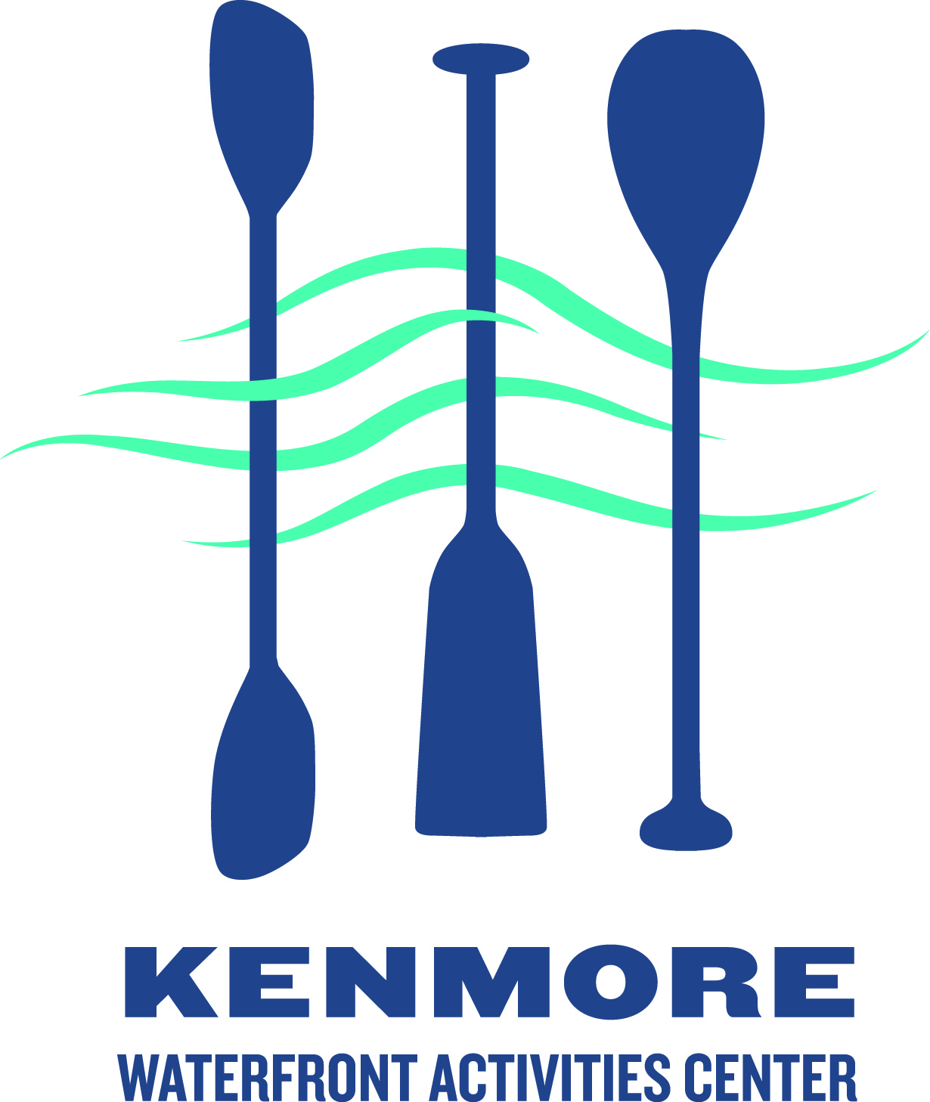
Kenmore Rowing Club
Adult Rowing Club Registration

Participant information

Last name:___________________________ First name:____________________ Sex: __M __ F

Date-of-birth: ____/______/____ e-mail: ____________________________________________

Phone number: (_______)_____________ ___cell ___landline

Street Address ___________________________________ City _____________ Zipcode __________

Registration type: ____$225 ___payment before March 1 (-$25)

T-shirt size: __ Womens __ Mens __small __medium __large __XL

How did you hear about us? ___Internet ___Flyer ___Word of mouth Other ___________________

Swimming acknowledgement:
_____ To participate in Club rowing I understand I must (a) pass a 10 minute float test (offered by
Initial Seattle Parks see link below), (b) provide other evidence of swimming ability, or (c) provide
information that demonstrates you are an experienced rower. Please provide evidence with your registration form Float test info http://www.seattle.gov/parks/pools.asp - call the pool for a schedule (see http://www.seattle.gov/parks/teens/pdf/forms/float_test.pdf)

Waiver acknowledgement:
_____ I understand that I will need to sign the USRowing waiver of liability before I participate
Initial

Medical conditions: please list any current injuries, physical/mental limitations, allergies, and any other pertinent medical information that the program director and coaching staff may need to be aware of to ensure you have a safe and productive rowing experience.

____________________________________________________________________________________

____________________________________________________________________________________

Emergency Medical Treatment Waiver - In case of emergency, please contact:

Name: ____________________________________ Phone: ____________________________

I authorize emergency medical treatment if qualified medical personnel consider treatment necessary providing I am unavailable to respond/advise or my emergency contact is unavailable to respond/advise.

Signature: _________________________________Date: _____/______/_______

Please make check payable to: Kenmore Waterfront Activities Center (memo line: Adult rowing)
Mail form and payment to: Kenmore WAC 7353 NE 175th St., Kenmore, WA 98028

