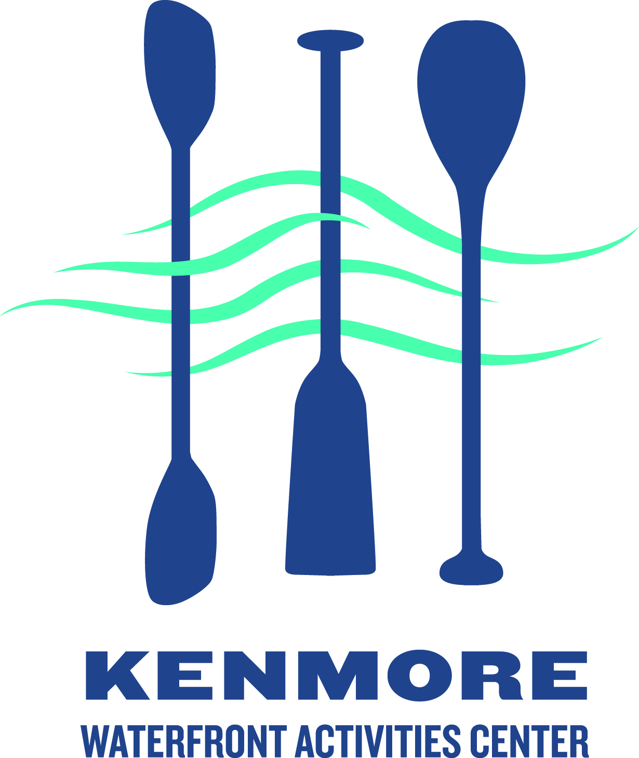
Kenmore Rowing Club
Adult Rowing Club Registration

Participant information

Last name:___________________________ First name:____________________ Sex: __M __ F

Date-of-birth: ____/______/____ e-mail: ____________________________________________

Phone number: (_______)_____________ ___cell ___landline

Street Address ___________________________________ City _____________ Zipcode __________

Registration type: ____$225 ___payment before March 1 (-$25)

How did you hear about us? ___Internet ___Flyer ___Word of mouth Other ___________________

Swimming acknowledgement:
_____ I understand that, to participate in Club rowing on an ongoing basis, I must pass a 10 minute
float test (or provide other evidence of swimming ability) if I am not already an experienced
rower. The float test can be taken at a number of Seattle Parks and Recreation Pools
http://www.seattle.gov/parks/pools.asp - call the pool for a schedule
(see http://www.seattle.gov/parks/teens/pdf/forms/float_test.pdf)

Waiver acknowledgement:
_____ I understand that I will need to sign the USRowing waiver of liability before I participate
Initial

Medical conditions: please list any current injuries, physical/mental limitations, allergies, and any other pertinent medical information that the program director and coaching staff may need to be aware of to ensure you have a safe and productive rowing experience.

____________________________________________________________________________________

____________________________________________________________________________________

Emergency Medical Treatment Waiver - In case of emergency, please contact:

Name: ____________________________________ Phone: ____________________________

I authorize emergency medical treatment if qualified medical personnel consider treatment necessary providing I am unavailable to respond/advise or my emergency contact is unavailable to respond/advise.

Signature: _________________________________Date: _____/______/_______

Please make check payable to: Kenmore Waterfront Activities Center (memo line: Adult rowing)
Mail form and payment to: Kenmore WAC 7353 NE 175th St., Kenmore, WA 98028

